Rock Crawler Hauler

Best Ride in an F250

I have more to say on this than most. I have had lots of F150's. When I got my 2020 F250 7.3 my wife hated the ride and it did ride a lot rougher than an F150. So I started out improving the ride. I started with the spacers. Then lots of different shocks. The 2020's have so little travel in the front that it is a problem.
The first improvement is to go to a Tremor stabilizer bar. The next ting to do is go to a progressive spring. Then the shocks need lots more travel and the rear springs are too stiff.
The front Shocks that I am running are Bilstein for a Jeep Wrangler JKU with a 4" lift.
The front springs are Progressive Synergy for an F250 with about a 2" level.
The Rear Springs are Carli 12 leaf.
The rear shocks are Monroe with same travel as stock.
Since I am running a larger tire I can carry the same weight with only 38psi. Forscan adjusted for lower pressure.
It really rides and handles great and will go thru really bad dips at 20mph without hitting bottom.
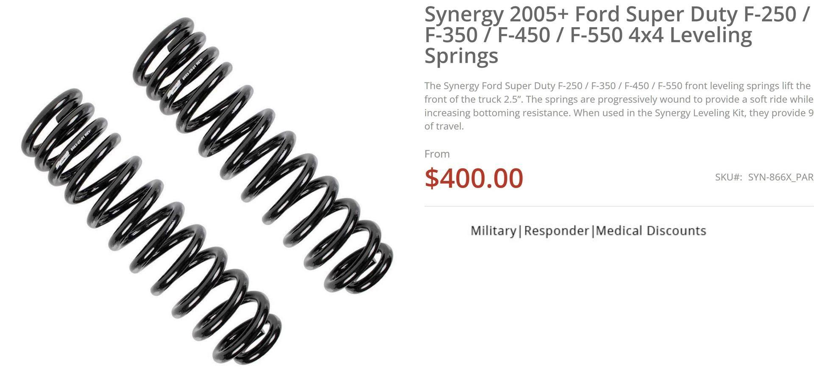
Synergy progressive springs
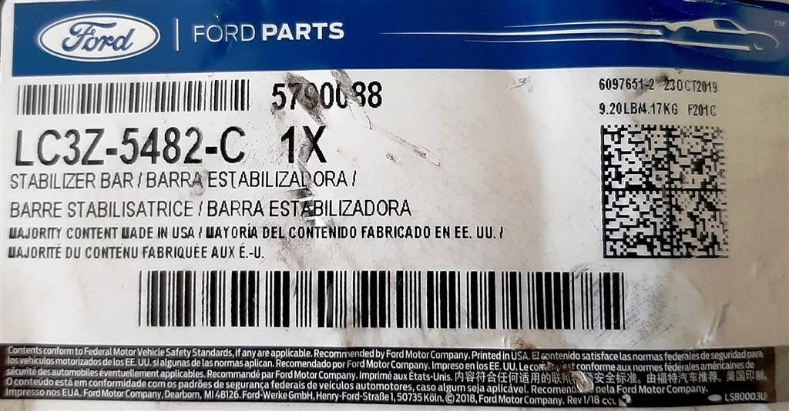
Tremor Swaybar
Here are some part numbers and pictures from another post I made.
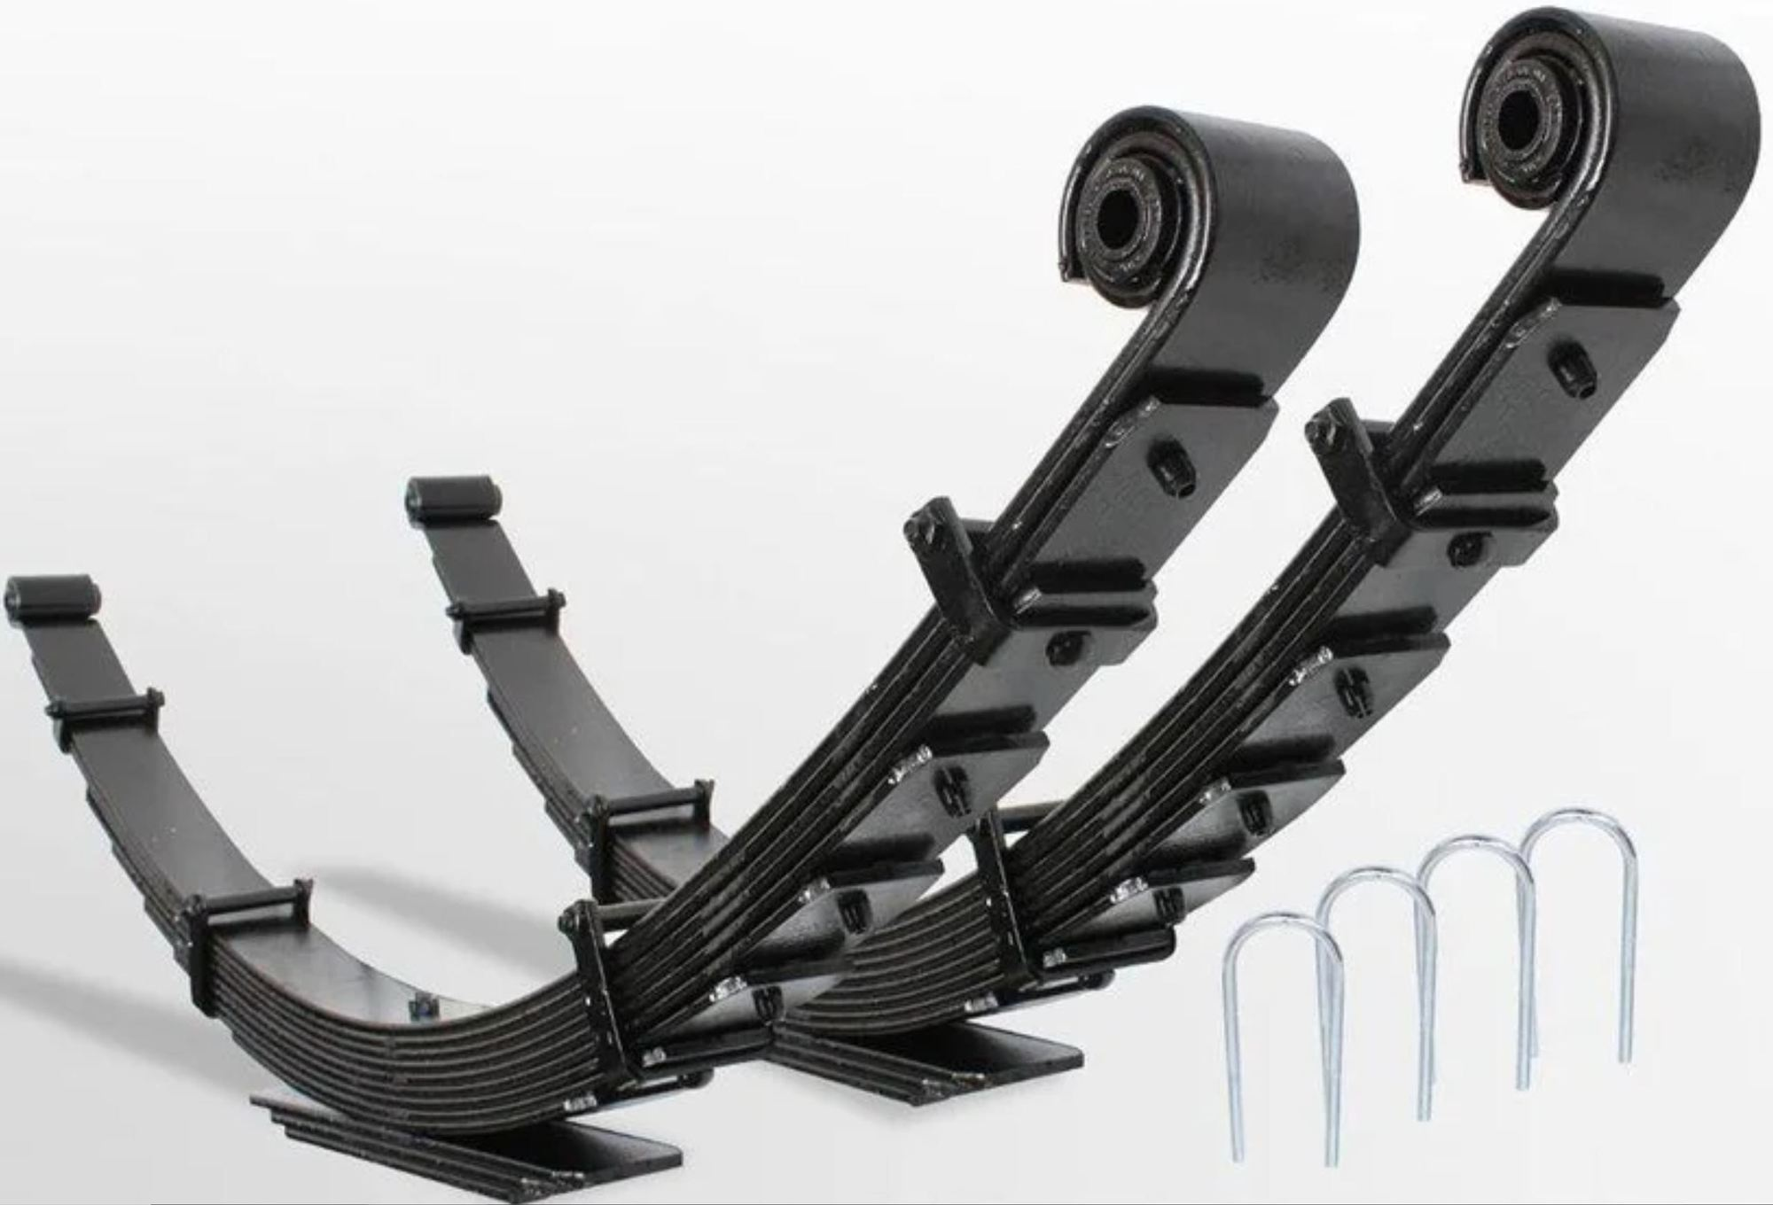
Carli Leafs
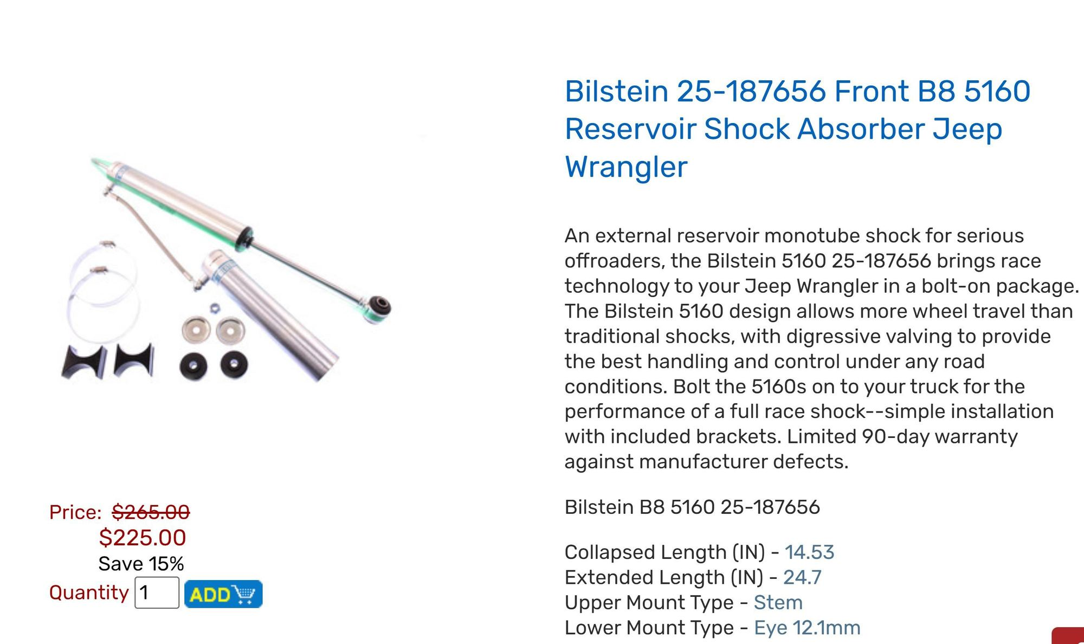
Bilstein Jeep shocks with lower bushing changed to fit F250
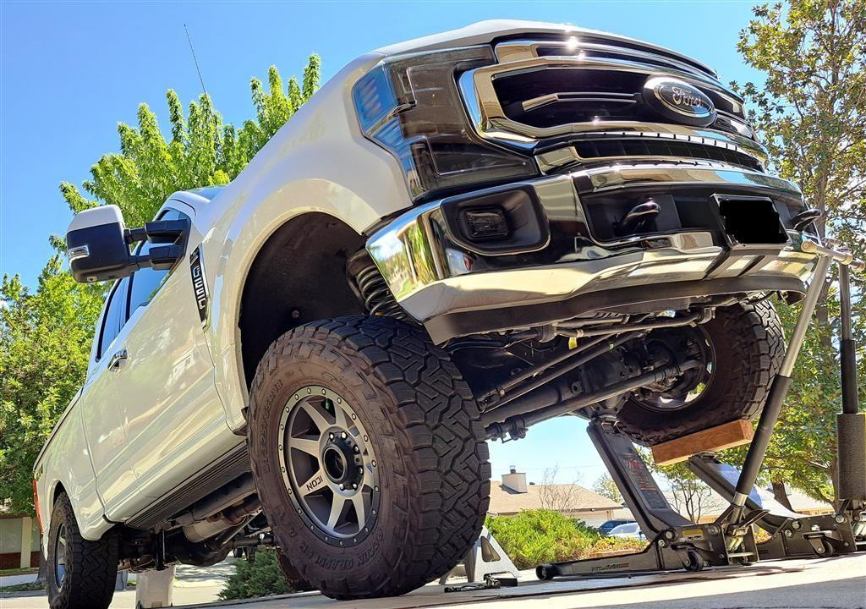
F250


